# Lab report: vpn tunneling

Name: Guo Yuchen

Student ID: 1004885

## Task 1: Network Setup

• Host U can communicate with VPN Server.

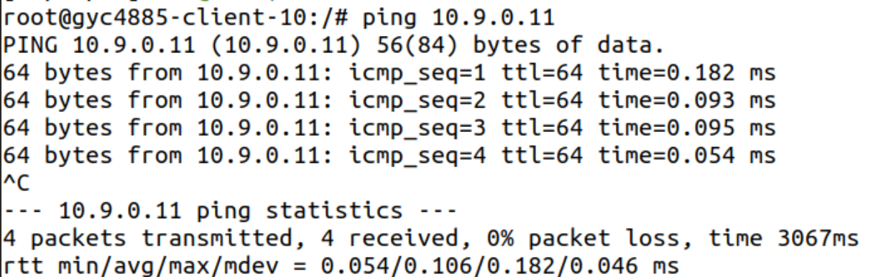

• VPN Server can communicate with Host V.

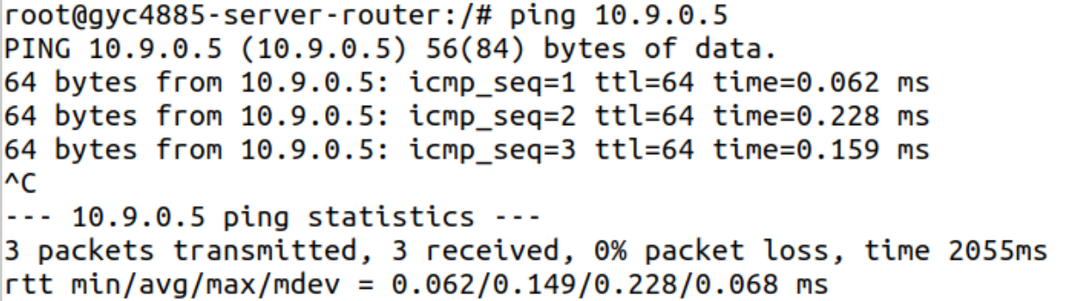

• Host U should not be able to communicate with Host V.

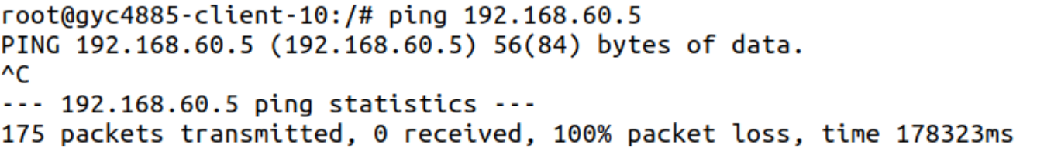

• Run tcpdump on the router, and sniff the traffic on each of the network. Show that you can capture packets.

192.168.60.5 ping 192.168.60.6

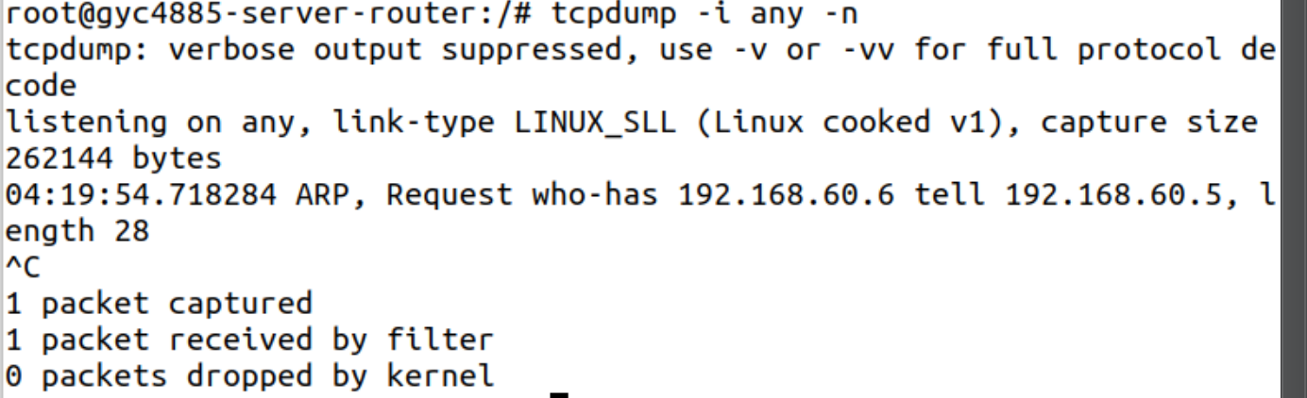

192.168.60.6 ping 10.9.0.5

10.9.0.5 ping 10.9.0.11

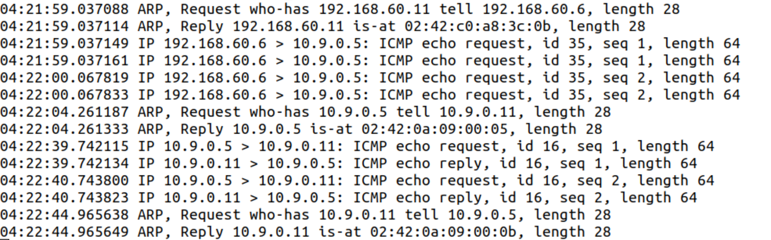

## Task 2: Create and Configure TUN Interface

### Task 2.a: Name of the Interface

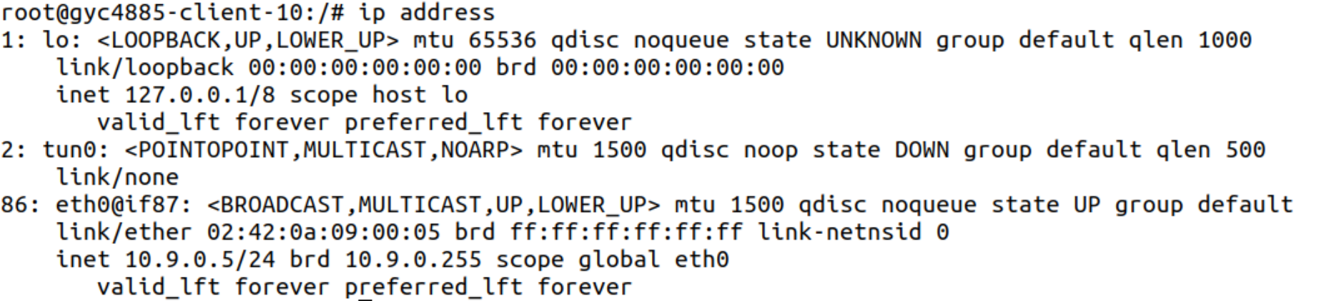

Change name:

ifr = struct.pack('16sH', b'guo%d', IFF_TUN | IFF_NO_PI)

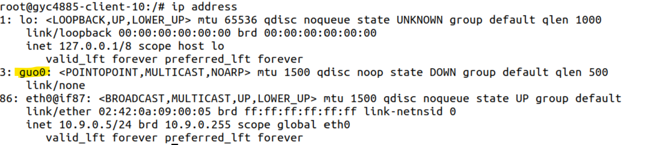

### Task 2.b: Set up the TUN Interface

After assigning ip address and bring up the interface:

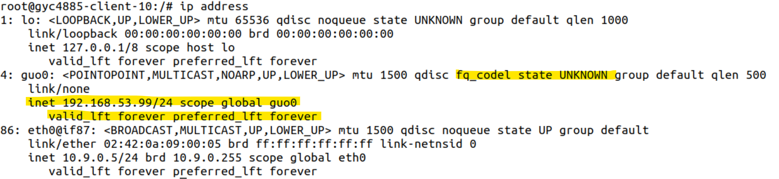

The state id not DOWN, and an ip address is assigned.

### Task 2.c: Read from the TUN Interface

Ping 192.168.53.1 from host U:

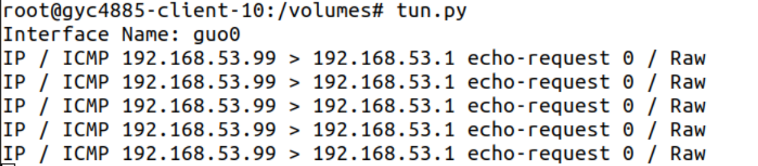

The message from Host U is sent to 192.168.53.1.

Ping 192.168.60.5:

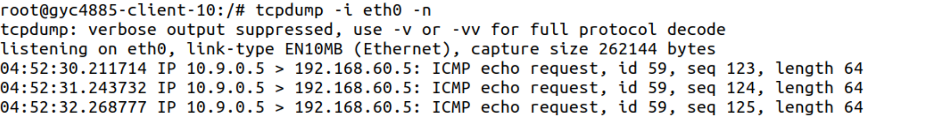

tun.py does not print out anything? Because any network outside of the host network is unreachable since the tunnel is not established on the other side.

### Task 2.d: Write to the TUN Interface

• After getting a packet from the TUN interface, if this packet is an ICMP echo request packet, construct a corresponding echo reply packet and write it to the TUN interface.

The code is as follows:

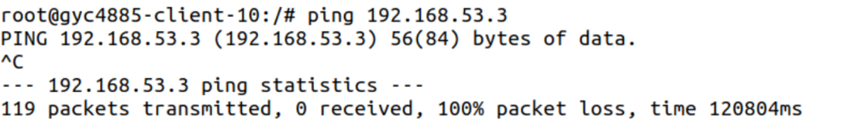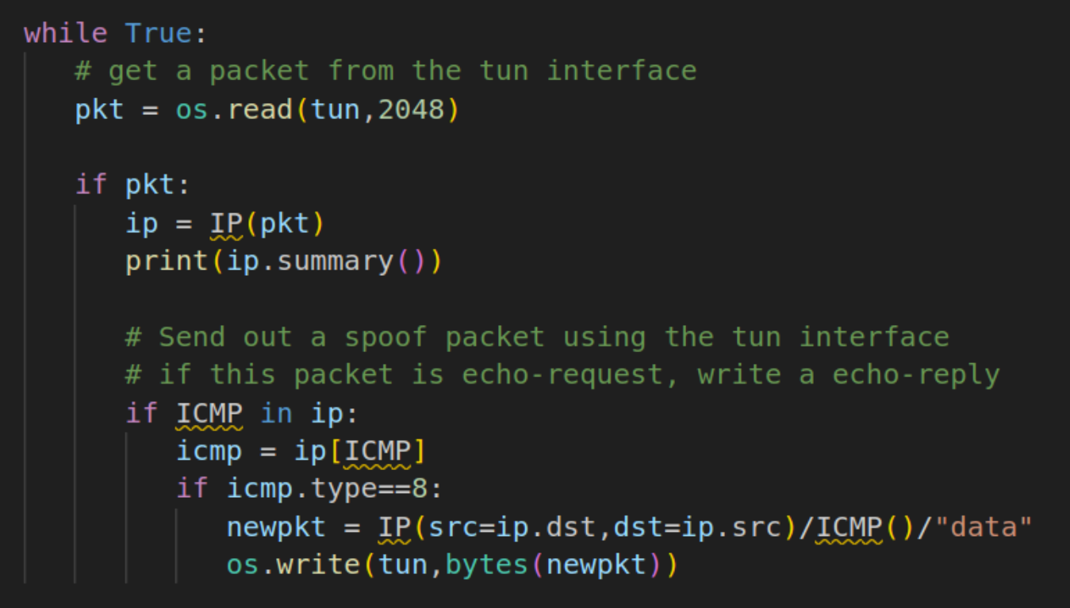

tun received the packet, and replied.

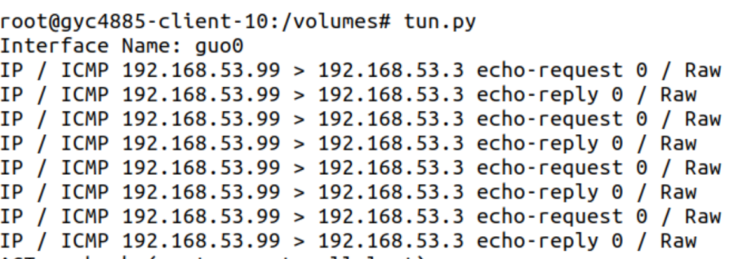

• Instead of writing an IP packet to the interface, write some arbitrary data to the interface:

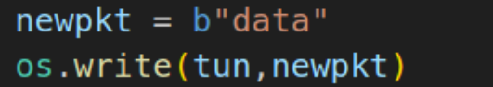

Tun received the packet, but does not reply correct content.

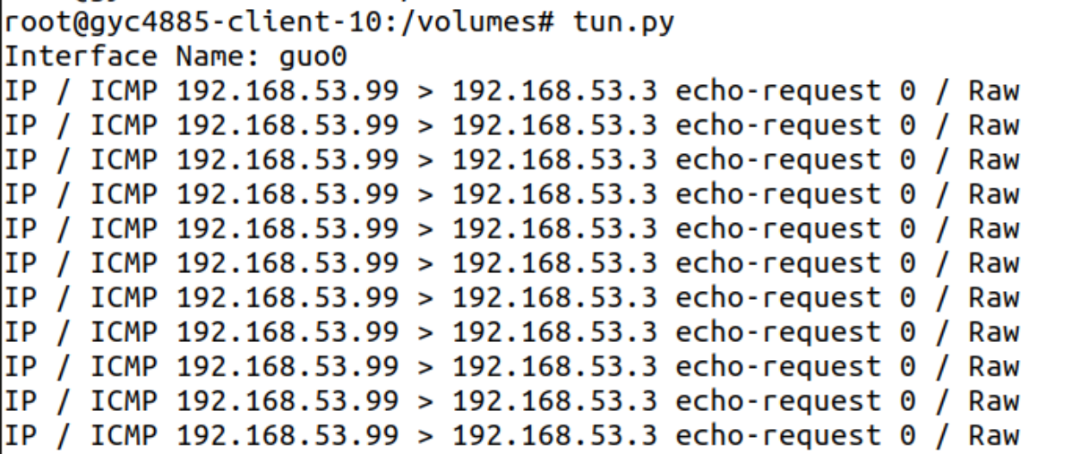

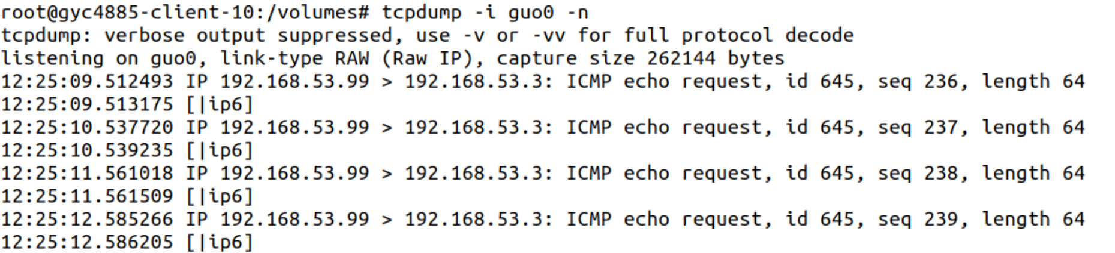

## Task 3: Send the IP Packet to VPN Server Through a Tunnel

Ping 192.168.53.3 from host U:

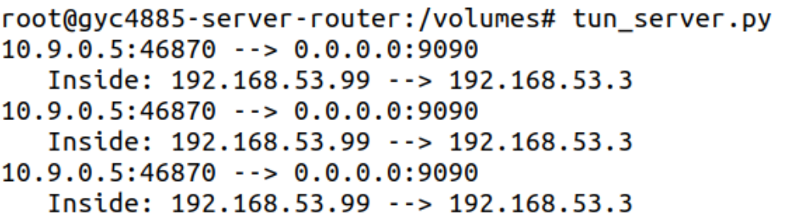

Original ip source address is U’s ip address, but the new ip packet’s src ip is 192.168.53.99

Ping host V:

ICMP packet is NOT sent to VPN Server through the tunnel. Add ip route as follows:



Then when ping an IP address in the 192.168.60.0/24 network, the ICMP packets are received by tun_server.py through the tunnel.

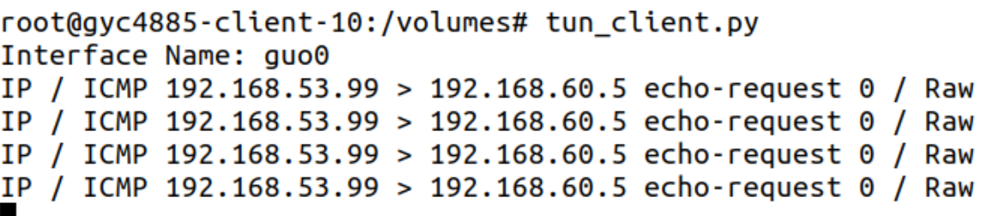

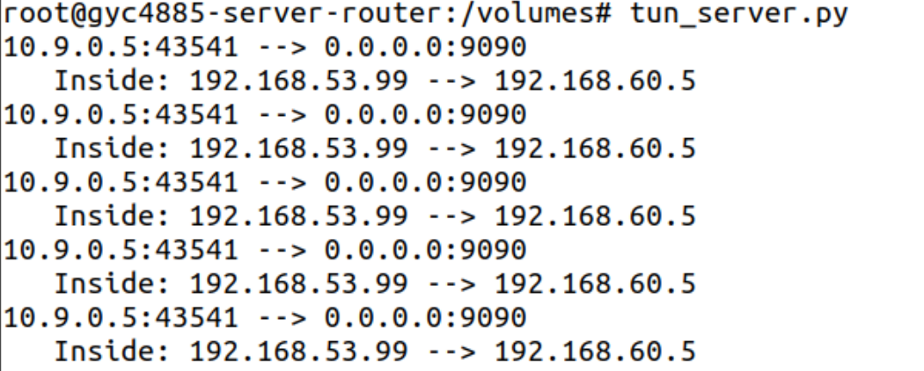

## Task 4: Set Up the VPN Server

tun_client.py:

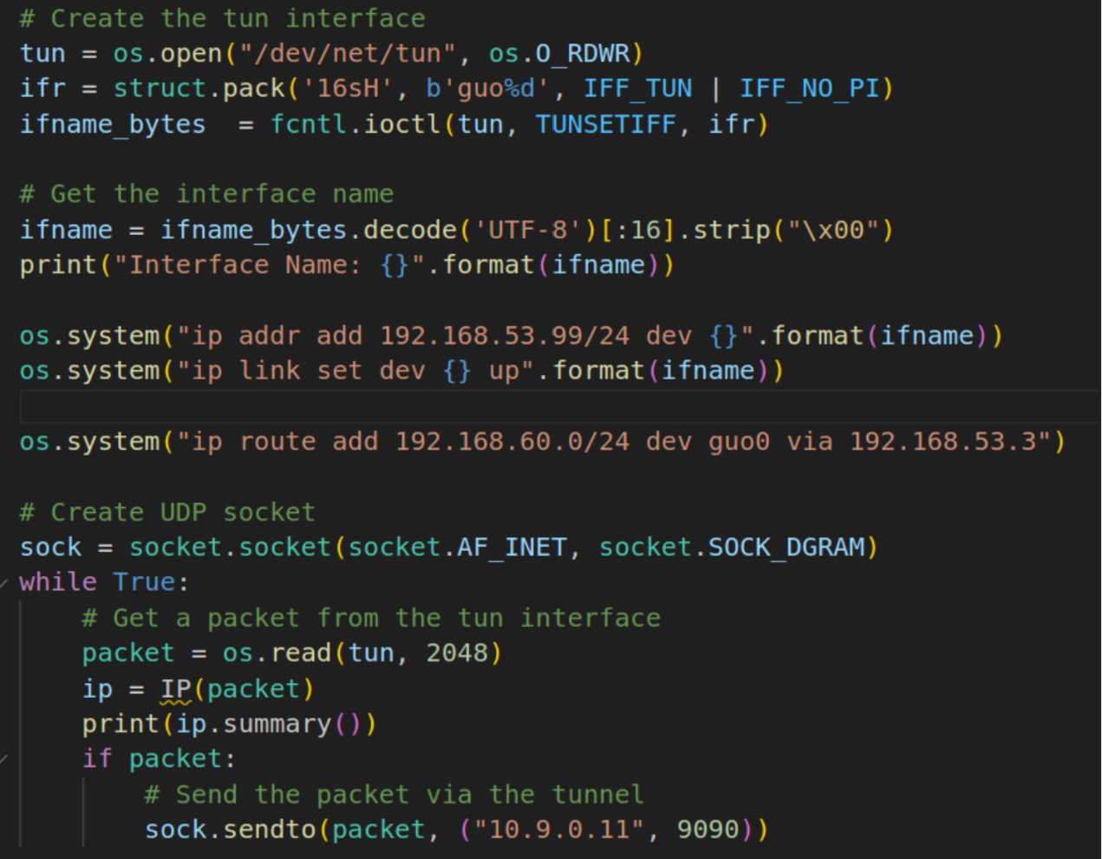

tun_server.py:

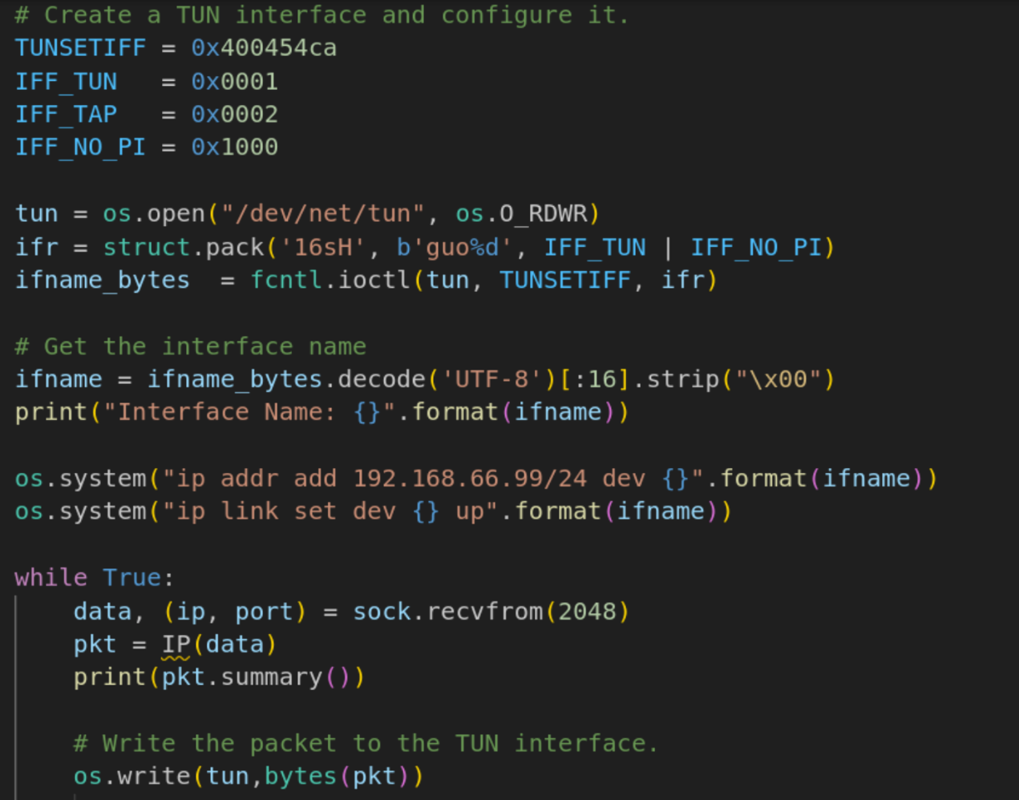

Ping Host V from Host U:

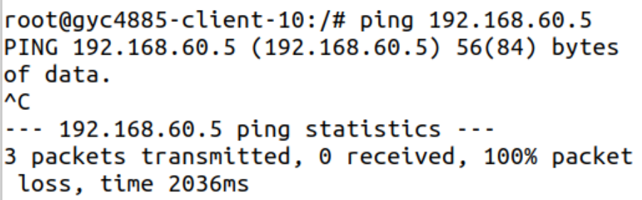

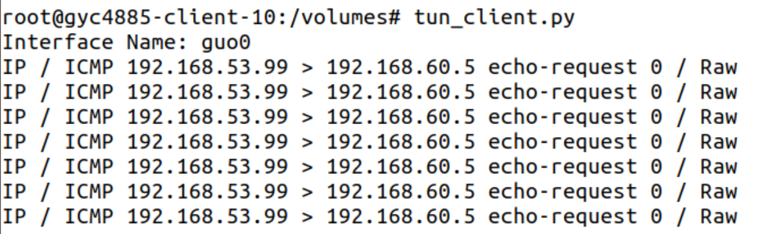

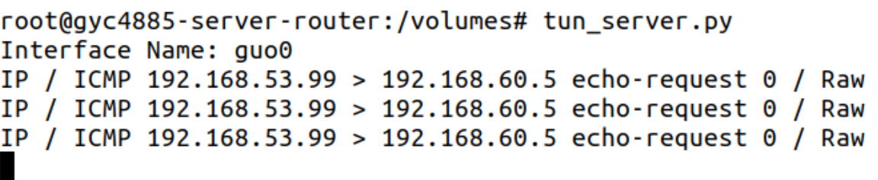

The ICMP echo request packets arrive at Host V through the tunnel.

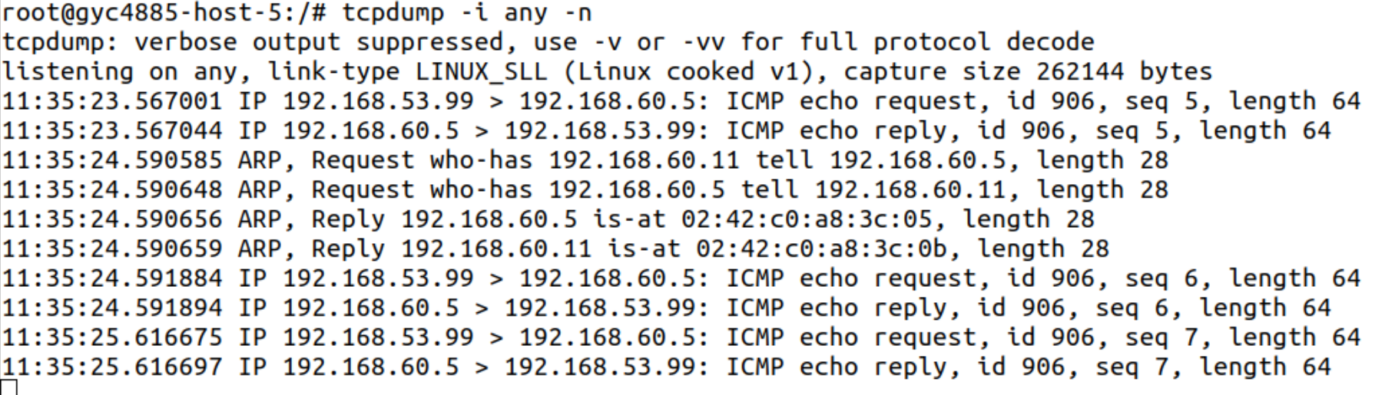

## Task 5: Handling Traffic in Both Directions

tun_server.py:

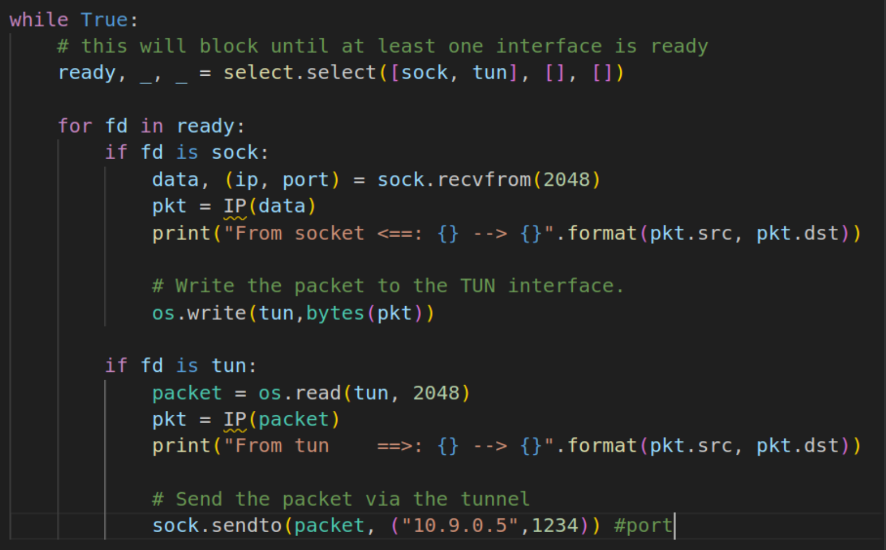

tun_client.py:

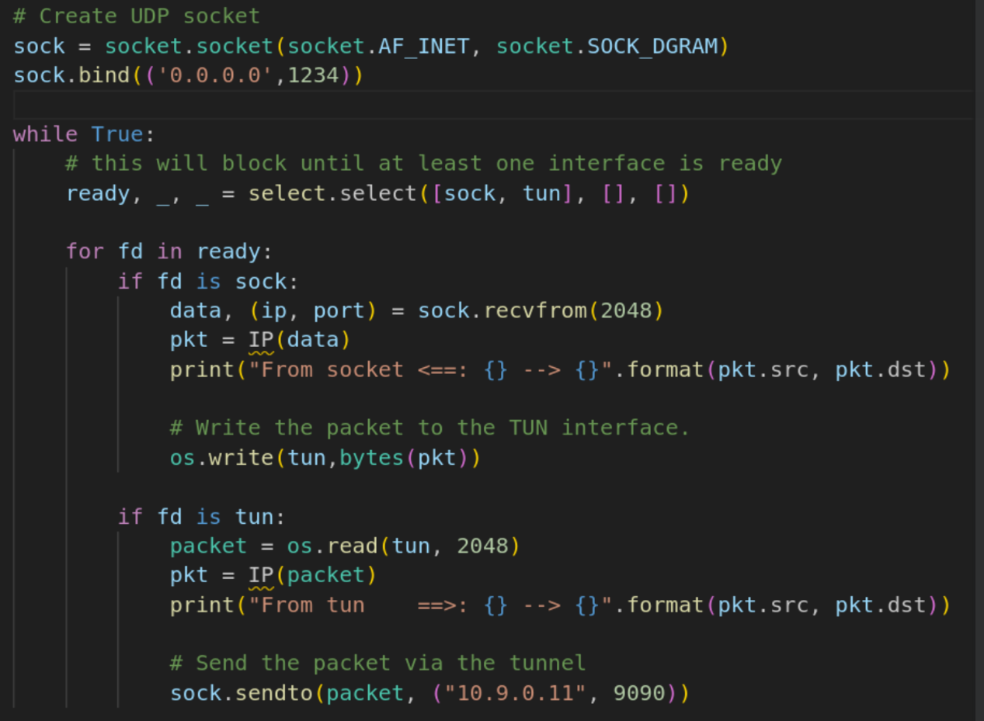

Ping Host V from Host U: both sides can send and receive packets.

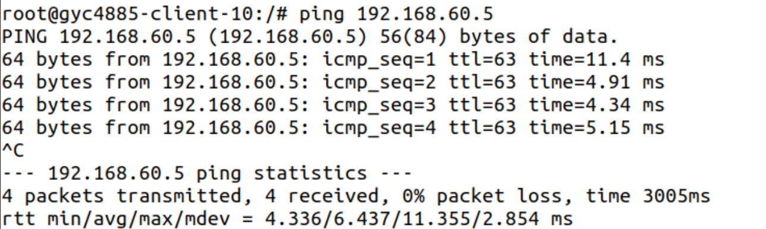

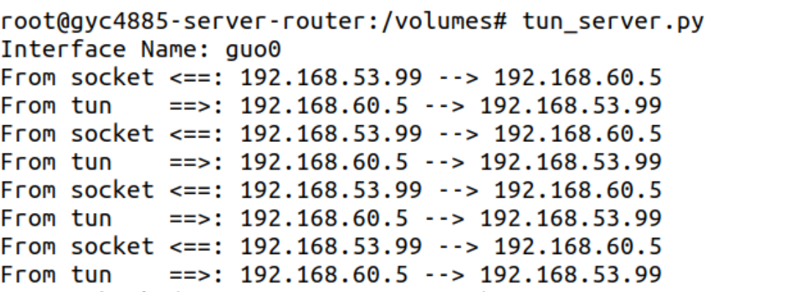

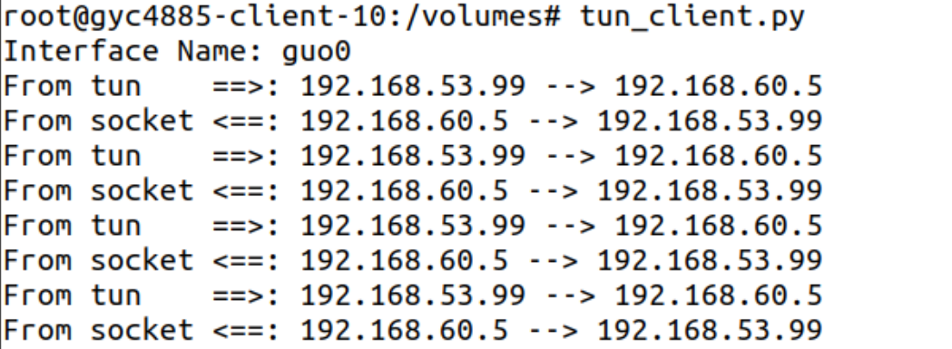

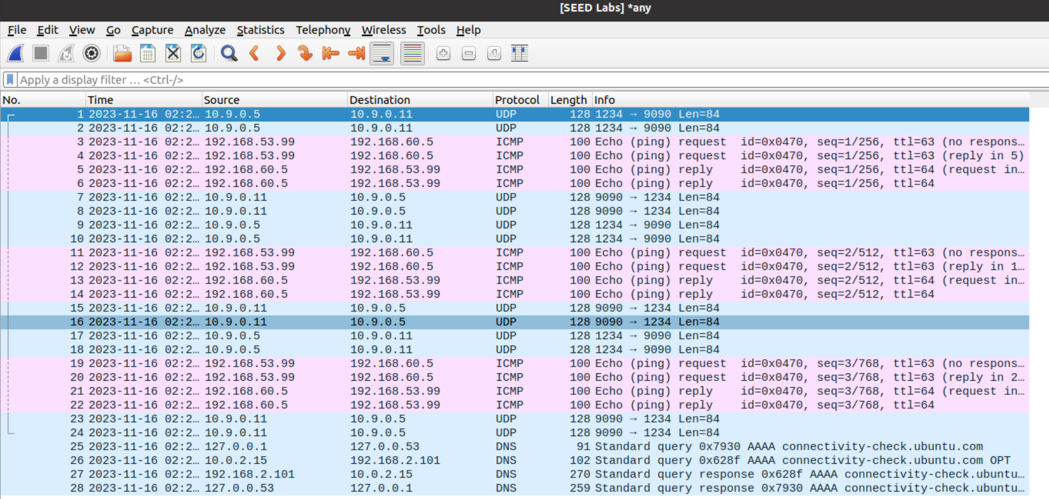

* Host U sends ping request to VPN server by tun through tunnel
* VPN server sends ping request to Host V
* Host V sends echo reply to VPN server
* VPN server sends echo reply to Host U by tun through tunnel

telnet:

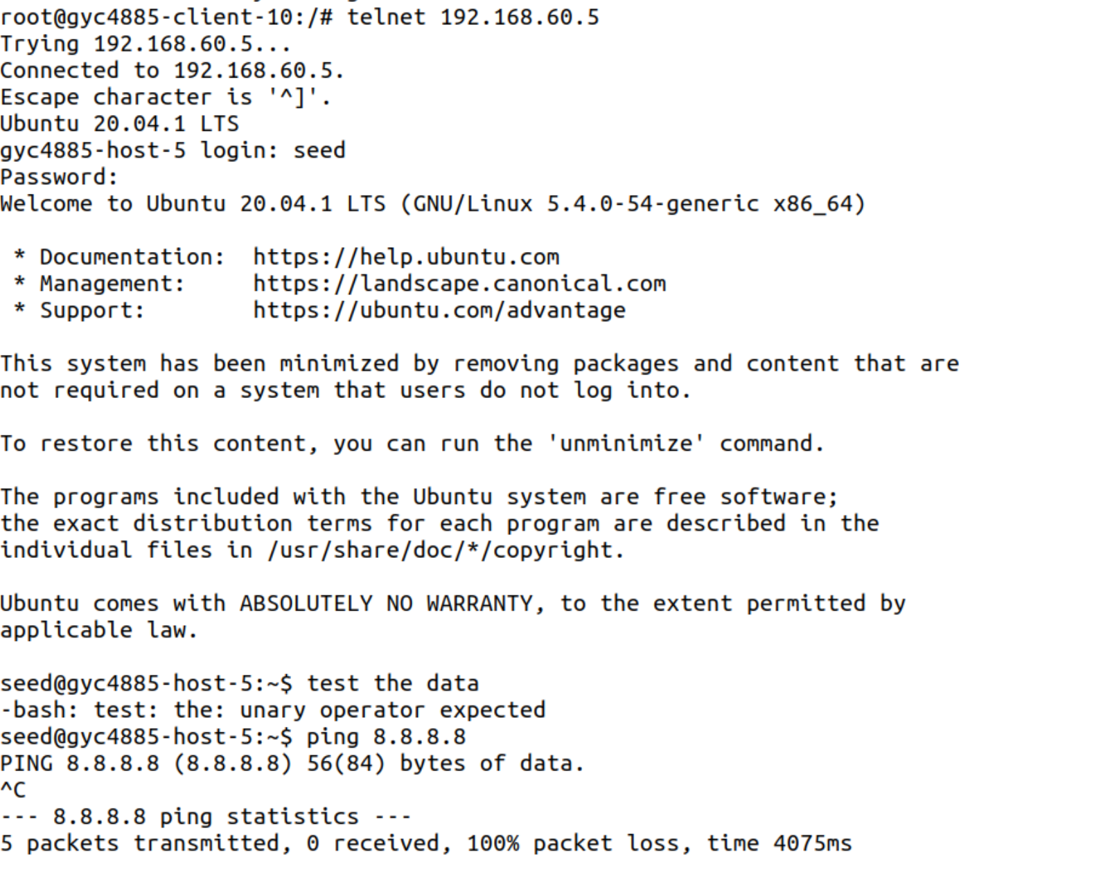

on client:

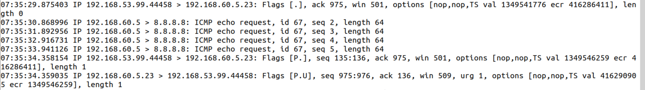

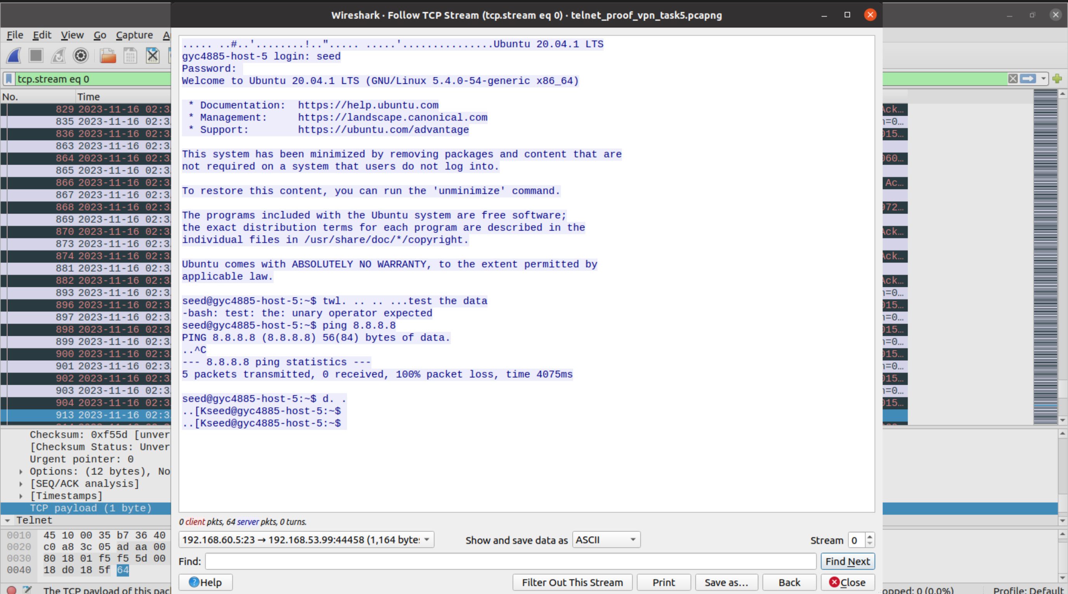

Data flow: Host U -> tun_client -> tun_server -> VPN server -> Host V

Vice versa for packets from host v to host u.

**Task 6: Tunnel-Breaking Experiment**

Break the VPN tunnel by terminating tun client and server programmes.. We are not able to type anything because the connection was broken.

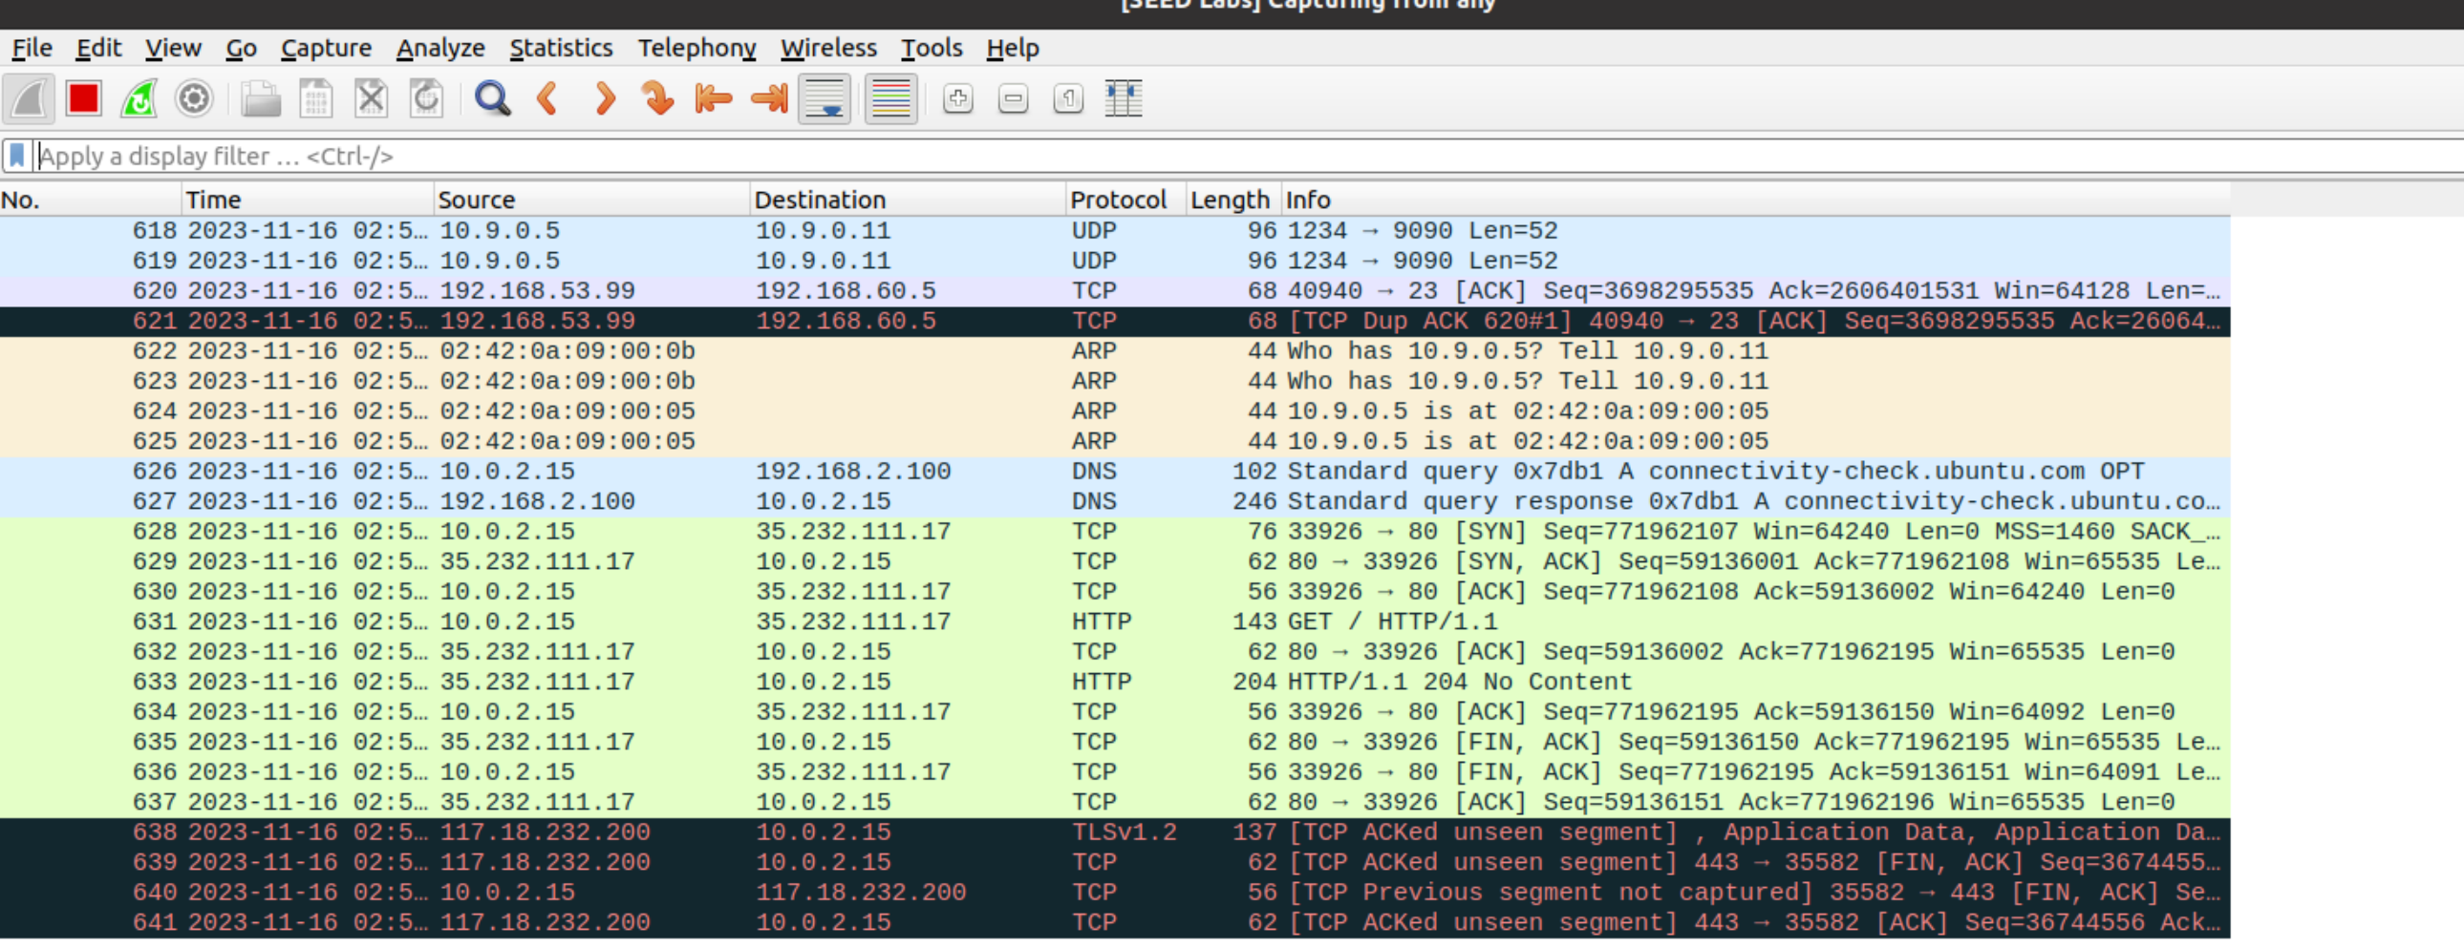

Reconnect the VPN tunnel, everything typed just now (which was not able to be seen) suddenly shows up, and the connection is re-established.

